# CS 499 Module One Assignment Template

Complete this template by replacing the bracketed text with the relevant information.

1. **Self-Introduction:** Address all of the following questions to introduce yourself.
   1. How long have you been in the Computer Science program?

**After graduating high school in Las Vegas, NV, I began my academic journey at a community college, where I focused on completing my general education classes. After consideration I found that the Computer Science Program at SNHU better fit my goals. I enrolled at SNHU during the year 2020 and have spent four years studying here.**

* 1. What have you learned while in the program? List three of the most important concepts or skills you have learned.

**Throughout the program I have learned many new concepts and skills. Three of the most important concepts I have learned about are the software development lifecycle, understanding and being proficient in new programming languages, as well as technical concepts like databases, algorithms, and more.**

* 1. Discuss the specific skills you aim to demonstrate through your enhancements to reach each of the course outcomes.

**The skills I aim to demonstrate in my enhancements are ones I have learned at SNHU and on a personal level. Some of the skills I would like to demonstrate is my proficiency in developing, testing, and providing solutions to problems in my code. My overall goal is to showcase my understanding of the course outcomes by applying them to my enhancements. Making sure to provide code that is understandable and manageable as well as sticking to the deadline.**

* 1. How do the specific skills you will demonstrate align with your career plans related to your degree?

**The specific skills I plan to demonstrate align with my career plans related to my Computer Science degree. Looking ahead to my career, I envision myself becoming a software engineer that has a strong foundation to be applied to the real world. Committing to deliver code that is efficient, well structured, and secured with high quality in a professional career setting.**

* 1. How does this contribute to the specialization you are targeting for your career?

**Having recently completed CS:360 Mobile Architecture and Programming, I have gained a passion for mobile development. The course allowed me to gain a better understanding of the entire development process. From planning and design to coding and testing, ensuring functionality. This experience has given me the confidence in understanding client needs and applying them to a final working application.**

1. **ePortfolio Set Up:**
   1. Submit a **screen capture** of your ePortfolio home page that clearly shows your URL.
      1. You already have a repository in GitHub where you uploaded projects in previous courses. Your ePortfolio will reside in GitHub but can link to work at other sites, such as Bitbucket.
   2. Use the GitHub Pages link in the Resource section for directions on:
      1. How to create your GitHub website and publish code to GitHub Pages
      2. Issues, such as adding links to other sites
   3. Paste a screenshot of your GitHub Homepage with your URL clearly showing in the space below.

1. **Enhancement Plan:** 
   1. **Category One:** Software Engineering and Design
      1. **Select an** **artifact** that is **aligned with** **the** software engineering and design **category** and explain its origin. Submit a file containing the code for the artifact you choose with your enhancement plan.

**The artifact that I'm choosing that aligns with the software engineering and design category is my Inventory Application. This application was developed in the CS 360: Mobile Architecture and Programming course.**

Note: Your artifact may be work from the following courses:

* IT 145: Foundation in Application Development
* CS 250: Software Development Lifecycle
* CS 260: Data Structures and Algorithms
* IT 315: Object Oriented Analysis and Design
* CS 320: Software Testing, Automation, and Quality Assurance
* CS 330: Computational Graphics and Visualization
* CS 340: Advanced Programming Concepts
* CS 350: Emerging Systems Architectures and Technologies
* CS 360: Mobile Architecture and Programming
* IT 365: Operating Environments
* IT 380: Cybersecurity and Information Assurance
* CS 405: Secure Coding
* CS 410: Reverse Software engineering
* IT 340: Network and Telecommunication Management
* IT 380: Cybersecurity and Information Assurance
  + 1. **Describe** a practical, well-illustrated **plan** for enhancement in alignment with the category, including a pseudocode or flowchart that illustrates the planned enhancement.

**For category one, my plan for enhancement is expand on to my current applications user account. I would like to request new users to register with an email address. In addition, I plan to incorporate a side menu. Within the menu I plan to add log out functionality, allowing for the logged in user to log out of the account. As well within the side bar menu I plan to add an account settings button. Pressing the button will prompt the user to a new screen allowing the user to change their email, username, password, or to delete their account.**

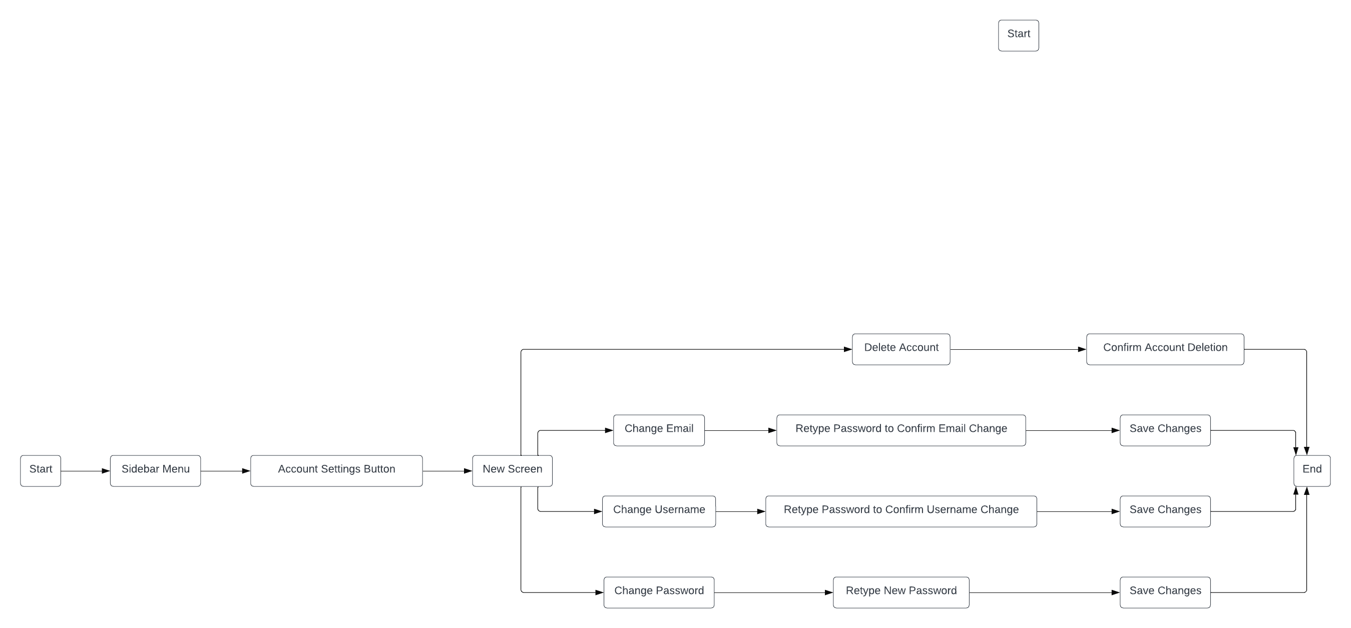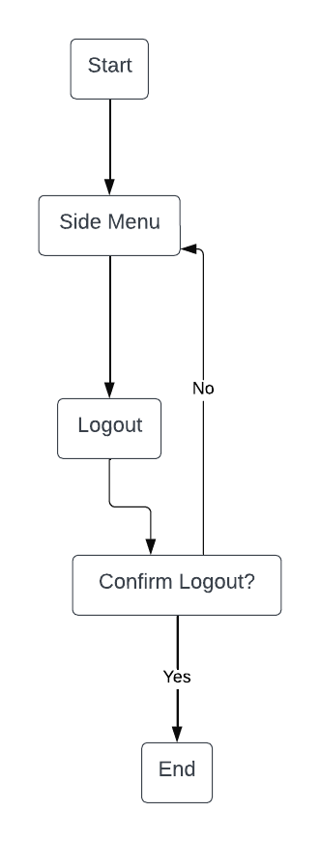

For this category of enhancement, consider improving a piece of software, transferring a project into a different language, reverse engineering a piece of software for a different operating system, or expanding a project’s complexity. These are just recommendations. Consider being creative and proposing an alternative enhancement to your instructor.

Think about what additions to include to complete the enhancement criteria in this category. Since one example option is to port to a new language, that is the kind of scale that is expected. This does not mean you need to port to a new language but instead have an equivalent scale of enhancement. Underlying expectations of any enhancement include fixing errors, debugging, and cleaning up comments, but these are not enhancements themselves.

* + 1. Explain how the planned enhancement will **demonstrate** specific **skills** and align with course outcomes.
       1. Identify and describe the specific skills you will demonstrate that align with the course outcome.

**In my planned enhancement I will demonstrate skills that will align with the course outcome. I will demonstrate my proficiency in JAVA within Android Studio specifically in mobile development. Incorporating a side menu will also demonstrate my understanding of UI/UX design, allowing for an overall better user experience. Lastly, this will demonstrate a security mindset ensuring secured user data.**

* + - 1. Select one or more of the course outcomes below that your enhancement will align with.
* **Design and evaluate computing solutions that solve a given problem using algorithmic principles and computer science practices and standards appropriate to its solution while managing the trade-offs involved in design choices.**
* **Demonstrate an ability to use well-founded and innovative techniques, skills, and tools in computing practices for the purpose of implementing computer solutions that deliver value and accomplish industry-specific goals.**
* **Develop a security mindset that anticipates adversarial exploits in software architecture and designs to expose potential vulnerabilities, mitigate design flaws, and ensure privacy and enhanced security of data and resources.**

Course Outcomes:

* Employ strategies for building collaborative environments that enable diverse audiences to support organizational decision-making in the field of computer science.
* Design, develop, and deliver professional-quality oral, written, and visual communications that are coherent, technically sound, and appropriately adapted to specific audiences and contexts.
* Design and evaluate computing solutions that solve a given problem using algorithmic principles and computer science practices and standards appropriate to its solution while managing the trade-offs involved in design choices.
* Demonstrate an ability to use well-founded and innovative techniques, skills, and tools in computing practices for the purpose of implementing computer solutions that deliver value and accomplish industry-specific goals.
* Develop a security mindset that anticipates adversarial exploits in software architecture and designs to expose potential vulnerabilities, mitigate design flaws, and ensure privacy and enhanced security of data and resources.
  1. **Category Two:** Algorithms and Data Structures

1. **Select an artifact** that is **aligned with the** algorithms and data structures **category** and explain its origin. Submit a file containing the code for the artifact you choose with your enhancement plan. You may choose work from the courses listed under Category One.

**For Category Two: Algorithms and Data Structures, I will continue to use my Inventory Application.**

1. **Describe** a practical, well-illustrated **plan** for enhancement in alignment with the category, including a pseudocode or flowchart that illustrates the planned enhancement.

**For category two, my plan for enhancement involves implementing search functionality. This enhancement will include adding a user-friendly search bar to the inventory screen filtering through the items. This search functionality will utilize a linear search algorithm which will allow users to locate a specific item.**

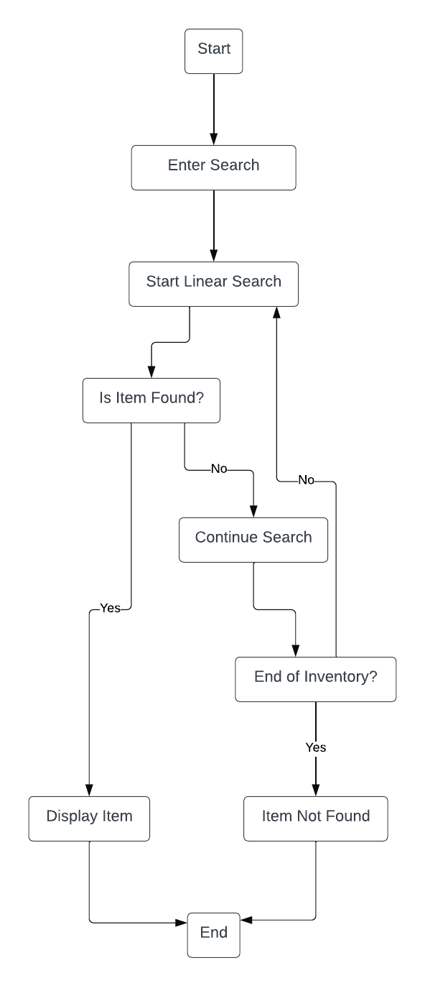

For this category of enhancement, consider improving the efficiency of a project or expanding the complexity of the use of data structures and algorithms for your artifact. These are just recommendations. Consider being creative and proposing an alternative enhancement to your instructor. Note: You only need to choose one type of enhancement per category.

Think about what additions to include to complete the enhancement criteria in this category. Since one example option is to port to a new language, that is the kind of scale that is expected. Perhaps you might increase the efficiency and time complexity of an algorithm in an application and detail the logic of the increased time complexity. Remember, you do not need to port to a new language but instead have an equivalent scale of enhancement. Underlying expectations of any enhancement include fixing errors, debugging, and cleaning up comments, but these are not enhancements themselves.

1. Explain how the planned enhancement will **demonstrate** specific **skills** and align with course outcomes.
   1. Identify and describe the specific skills you will demonstrate to align with the course outcome.

**The planned enhancement where implementing a search function aligns with the course outcome. This enhancement will showcase my ability to implement a search algorithm, specifically a linear search, to find items within a collection. The skills that I will demonstrate include the ability to design and implement algorithms, manage trade-offs in design choices, as well as apply appropriate data structures to optimize search operations.**

* 1. Select one or more of the course outcomes listed under Category One that your enhancement will align with.
* **Design and evaluate computing solutions that solve a given problem using algorithmic principles and computer science practices and standards appropriate to its solution while managing the trade-offs involved in design choices.**
* **Demonstrate an ability to use well-founded and innovative techniques, skills, and tools in computing practices for the purpose of implementing computer solutions that deliver value and accomplish industry-specific goals.**

**Top of Form**

* 1. **Category Three: Databases**
     1. **Select an artifact** that is **aligned with the** databases **category** and explain its origin. Submit a file containing the code for the artifact you choose with your enhancement plan. You may choose work from the courses listed under Category One.

**For category three: Databases, I will continue to use my Inventory Application.**

* + 1. **Describe** a practical, well-illustrated **plan** for enhancement in alignment with the category, including a pseudocode or flowchart that illustrates the planned enhancement.

**For category three, my plan for enhancement is to build upon the current database. My plan is to strengthen the security of my inventory application by implementing password hashing. Currently, my inventory application uses a SQLight database to store user passwords as plain text. In addition to password hashing, I would like to add password recovery for users. Developing a password recovery mechanism by generating password reset links. The enhancement will ensure a more secure storage 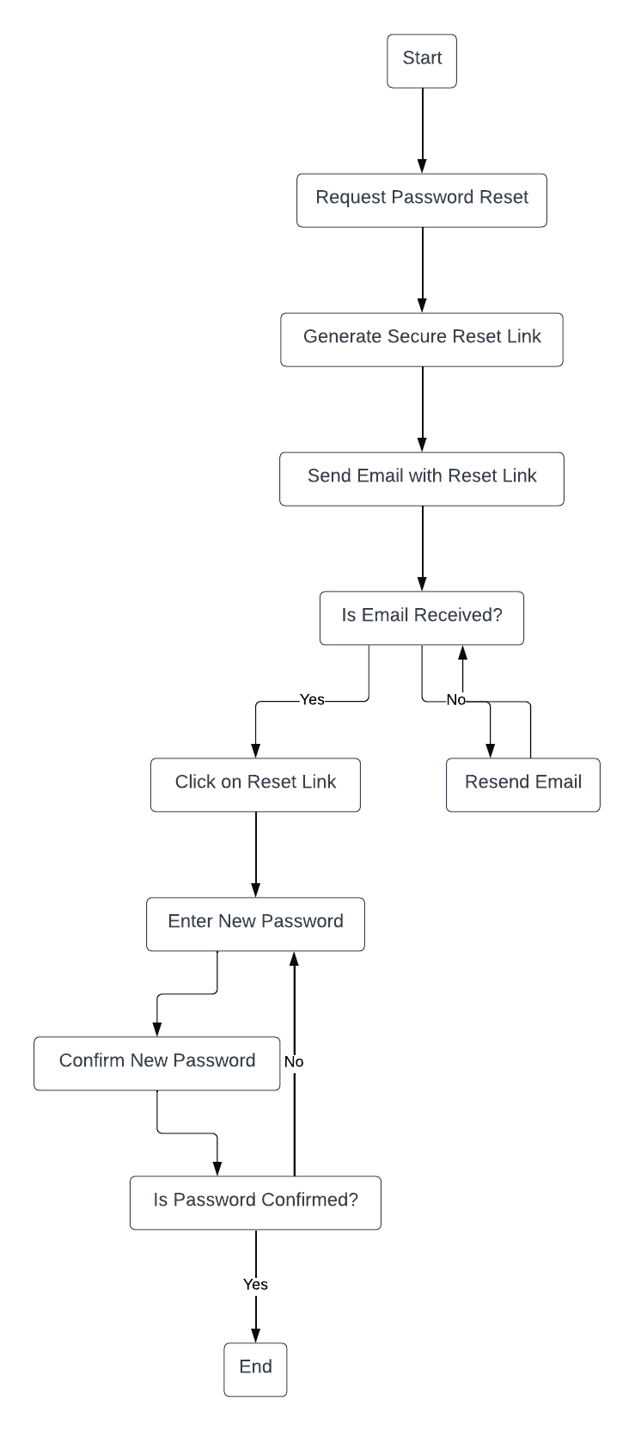method and user security.**

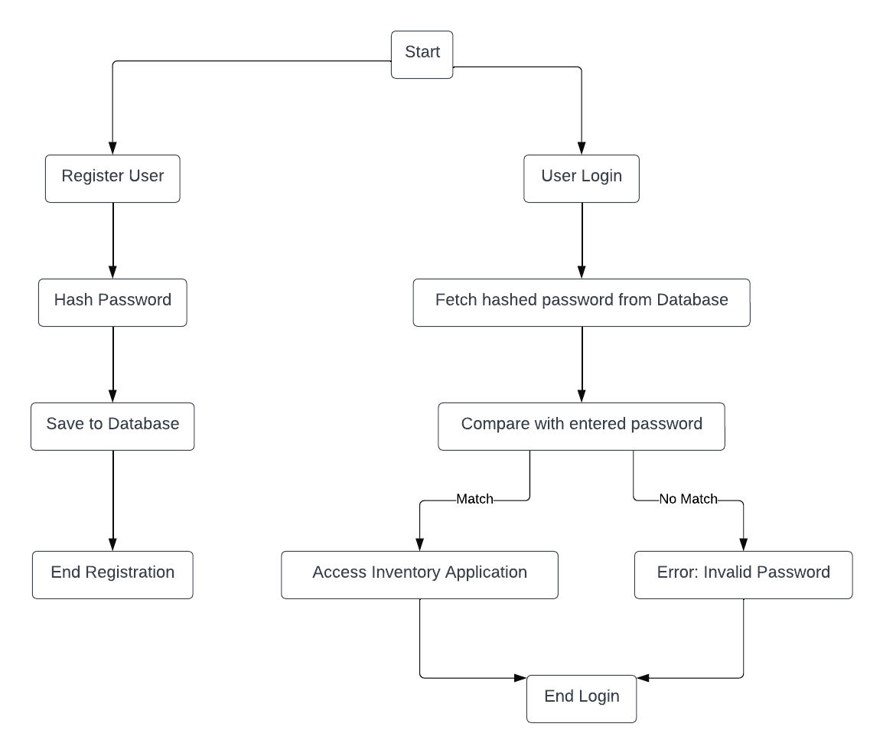

For this category of enhancement, consider adding more advanced concepts of MySQL, incorporating data mining, creating a MongoDB interface with HTML/JavaScript, or building a full stack with a different programming language for your artifact. These are just recommendations; consider being creative and proposing an alternative enhancement to your instructor. Note: You only need to choose one type of enhancement per category.

Think about what additions to include to complete the enhancement criteria in this category. Since one example option is to port to a new language, that is the kind of scale that is expected. Perhaps you might increase the efficiency and time complexity of an algorithm in an application and detail the logic of the increased time complexity. Remember, you do not need to port to a new language but instead have an equivalent scale of enhancement. Underlying expectations of any enhancement include fixing errors, debugging, and cleaning up comments, but these are not enhancements themselves.

* + 1. Explain how the planned enhancement will **demonstrate** specific **skills** and align with course outcomes.
       1. Identify and describe the specific skills you will demonstrate that align with the course outcome.

**Implementing password hashing in the database will enhance security to the user’s data as well as aligning with a security mindset. Also demonstrating the implementation of a secure database that adheres to industry specific goals. Showcasing competence in delivering technically sound solutions.**

* + - 1. Select one or more of the course outcomes listed under Category One that your enhancement will align with.
* **Design and evaluate computing solutions that solve a given problem using algorithmic principles and computer science practices and standards appropriate to its solution while managing the trade-offs involved in design choices.**
* **Demonstrate an ability to use well-founded and innovative techniques, skills, and tools in computing practices for the purpose of implementing computer solutions that deliver value and accomplish industry-specific goals.**
* **Develop a security mindset that anticipates adversarial exploits in software architecture and designs to expose potential vulnerabilities, mitigate design flaws, and ensure privacy and enhanced security of data and resources.**

1. **ePortfolio Overall Skill Set**
   1. Accurately describe the **skill set** to be illustrated by the **ePortfolio** **overall**.
      1. Skills and outcomes planned to be illustrated in the code review

**During my code review, I plan to discuss my existing code for my inventory application. Analyzing the existing code for weakness, limitations, and vulnerabilities. Also giving details of the code’s functionality and purpose. I expect to break the code review into three sperate categories. These categories consist of Software Design and Engineering, Algorithms and Data structures, and finally Databases. Throughout each category I will be discussing, I will explain my planned enhancements that follow the course outcomes.**

* + 1. Skills and outcomes planned to be illustrated in the narratives

**For my narrative section of the ePortfolio, I plan to explain my artifact in detail on why I selected it and what I have learned through the development process. This will enable me to showcase my abilities and skills. As well as explaining my enhancements and why these enhancements will improve my artifact.**

* + 1. Skills and outcomes planned to be illustrated in the professional self-assessment

**During the professional self-assessment I will provide an introduction for my ePortfolio. This will allow me to reflect on my experience at SNHU for the past four years as well as reflect on CS-499 Capstone course. The professional self-assessment will give me the opportunity to display my strengths in my future career path and in Computer Science in general.**